Board Member Terms Memo
Project Green (AI Digital Twin for Accounting Firms)
Board Member: Sameer Seddiq

Role & Scope

Role: Non-executive Board Member (Advisory capacity)

Expectations:
- Participate in quarterly board meeting (virtual, ~1 hour max).
- Maintain presence in the private project Discord and share expertise or feedback where appropriate.
- Provide opinions, perspective, and occasional technical guidance (no fixed deliverables).

Nature of Role: This is an advisory role only, not operational Sameer Seddiq has no fiduciary duties, managerial authority, or legal liability for company operations.

Compensation
Revenue Share: 0.25% of gross revenue earned by the project while Sameer Seddiq is an active board member. Paid quarterly, within 30 days after quarter-end, based on booked revenue.

Future Conversion:
If/when the project incorporates and formalizes equity structures, the 0.25% revenue share may be converted into equity (terms to be negotiated at that time).

No Guarantees: This arrangement has no guaranteed dollar value. Compensation is contingent entirely on project revenue.

Term & Termination
Term: Open-ended; effective immediately upon acceptance.

Termination: Either party may end this arrangement at any time with written notice (e.g., via email or Discord).

Survival: Compensation ends upon termination — no residual obligations unless separately agreed.

Notes
This memo is non-binding until formal incorporation. It represents a mutual understanding of advisory participation and revenue share only.
No ownership, equity, or debt obligations are granted under this memo.

✍️ Signature Advisory Board Member - Sameer Seddiq:
📅 Date: 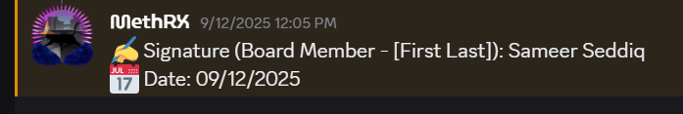

✍️ Signature (Founder, Project Green): Michael Leavenworth
📅 Date: 2/28/2026

